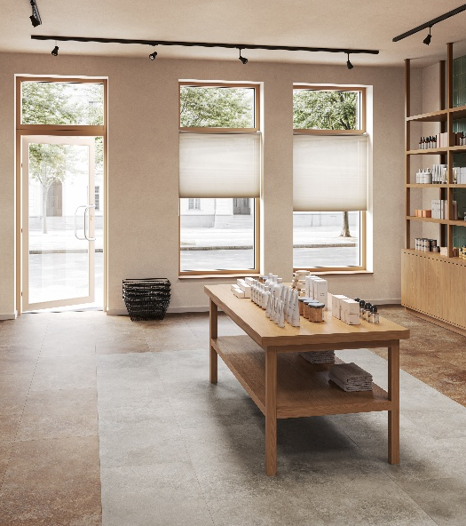
iD Classics & Naturals Glue-Down 70
Tender Datasheet

LUXURY VINYL TILE

iD Classics & Naturals Glue-Down 70 is a luxury vinyl tile for glue-down installation, with a total thickness of 2.5 mm and 0.55 mm wear layer. It offers a choice of 65 designs, including 35 in digital printing, in 8 different formats, including planks, mini-planks and tiles. A bevelled finish is also available, bringing added depth and elegance.

iD Classics & Naturals Glue-Down 70 belongs to EN 10582 and meets the European usage classification 23-34.

It will be 100% recyclable offcuts and post-use. Installation off cuts can be collected and recycled in new products through the Tarkett ReStart® program.

iD Classics & Naturals Glue-Down 70 contains a minimum of 34% recycled material and does not contain phthalate-based plasticizer.

iD Classics & Naturals Glue-Down 70 offers unique value thanks to its digital printing technology, which allows the décor to be printed without repetition over 12 m².

iD Classics & Naturals Glue-Down 70 features our TEKTANIUM PU coating that delivers unequalled resistance to scratches, abrasions, wear and stains. Moreover, it offers an ultra matt finish.

It offers a high dimensional stability of ≤ 0.10% according to the EN ISO 23999 standard.

It offers a high resistance to residual indentation with an average value of ≤ 0.05 mm according to the EN ISO 24343-1 standard.

iD Classics & Naturals Glue-Down 70 is classified R10 according to DIN EN 16165 NB.2, and according to the EN 13501-1 standard, the floor covering will offer a fire resistance classified Bfl s1.

Its emission rate of volatile organic compounds in air is less than 10 μg/m³, tested 28 days after installation according to ISO 16516.

The product will have a carbon footprint lower than 4 kg CO2 eq./m² (A1-A3 scope) and a total carbon footprint of lower than 3.5 kg CO2 eq./m² CO2 eq./m² (Module D).

The product benefits from an EPD & a MHS.

The product is made in Europe and comes with a 10-year commercial warranty.

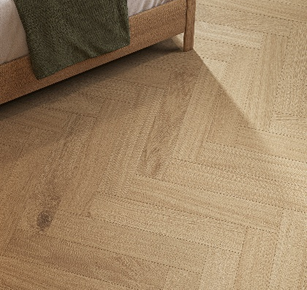
More reasons to choose Tarkett iD Classics & Naturals Glue-Down 70

- 100% Phthalate free
- 100% recyclable offcuts & post-use
- Optimal indoor air quality
- Test reports and certificates available upon request

- TVOC ≤ 100 μg/m³ after 28 days
- TEKTANIUM
- Made in Europe

