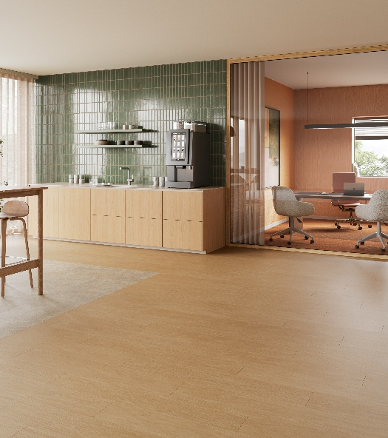
iD Classics & Naturals Click Ultimate 55
Tender Datasheet

LUXURY VINYL TILE

iD Classics & Naturals Click Ultimate 55 is a luxury vinyl tile for click installation, with a total thickness of 6.5 mm and 0.55 mm wear layer. It offers a choice of 65 designs, including 35 in digital printing, in 5 different formats, including planks and tiles. A beveled finish is bringing added depth and elegance.

iD Classics & Naturals Click Ultimate 55 belongs to EN 10582 and meets the European usage classification 23-33.

It is 100% recyclable offcuts and post-use. Installation off cuts can be collected and recycled in new products through the Tarkett ReStart® program.

iD Classics & Naturals Click Ultimate 55 contain of 20% recycled material and does not contain phthalate-based plasticizer.
iD Classics & Naturals Click Ultimate 55 offers unique value thanks to its digital printing technology, which allows the décor to be printed without repetition over 12 m² .

iD Classics & Naturals Click Ultimate 55 features our TEKTANIUM PU coating that delivers unequalled resistance to scratches, abrasions, wear and stains. Moreover, it offers an ultra matt finish.

It offers a high dimensional stability of ≤ 0.15% according to the EN ISO 23999 standard and can withstand temperatures up to 60°C. Integrated acoustic underlay provides in room walking noise reduction of 19dB.

It offers a high resistance to residual indentation with an average value of ≤ 0.1 mm according to the EN ISO 24343-1 standard.
iD Classics & Naturals Click Ultimate 55 is classified R10 according to DIN EN 16165 NB.2, and according to the EN 13501-1 standard, the floor covering will offer a fire resistance classified Bfl s1.

Its emission rate of volatile organic compounds in air is less than 10 μg/m³, tested 28 days after installation according to ISO 16516.

The product has a carbon footprint of below 12 kg CO2 eq./m² (A1–A3 scope) and a total carbon footprint below 6.5 kg CO2 eq./m² CO2 eq./m² (Module D).

Sustainability credentials are backed by an EPD & a MHS.

The product is made in Europe and comes with a 10-year commercial warranty.

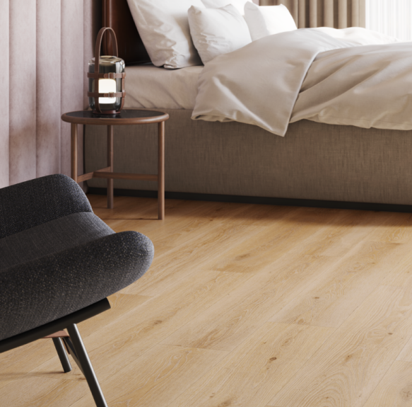

More reasons to choose Tarkett iD Classics & Naturals Click Ultimate 55

- 100% Phthalate free
- 100% recyclable offcuts & post-use
- Optimal indoor air quality
- Test reports and certificates available upon request

- TVOC ≤ 100 μg/m³ after 28 days
- TEKTANIUM
- Made in Europe

