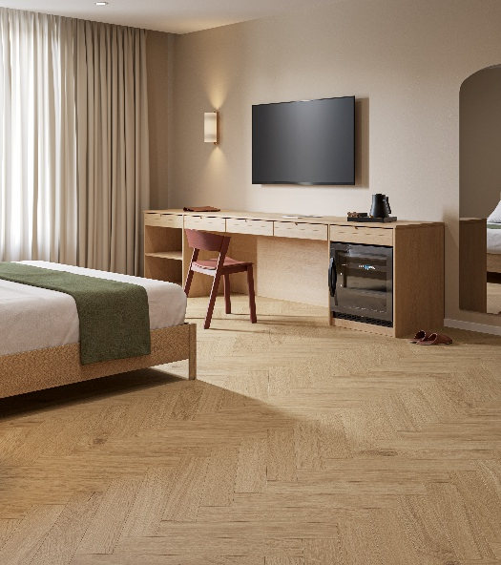
iD Classics Glue-Down 30
Tender Datasheet

LUXURY VINYL TILE

iD Classics Glue-Down 30 is a luxury vinyl tile for glue-down installation, with a total thickness of 2 mm and 0.30 mm wearlayer. It offers a choice of 30 designs in 4 different formats, including planks, mini-planks and tiles.
iD Classics Glue-Down 30 belongs to EN 10582 and meets the European usage classification 23-31.
It will be 100% recyclable offcuts and post-use. Installation off cuts can be collected and recycled in new products through the Tarkett ReStart® program.

iD Classics & Naturals Glue-Down 30 contain a minimum of 37% recycled material and does not contain phthalate-based plasticizer.

iD Classics Glue-Down 30 features our TEKTANIUM PU coating that delivers unequalled resistance to scratches, abrasions, wear and stains. Moreover, it offers an ultra matt finish.

It offers a high dimensional stability of ≤ 0.10% according to the EN ISO 23999 standard.
It offers a high resistance to residual indentation with an average value of ≤ 0.05 mm according to the EN SO 24343-1 standard.
iD Classics & Naturals Glue-Down 30 is classified R10 according to DIN EN 16165 NB.2, and according to the EN 13501-1 standard, the floor covering will offer a fire resistance classified Bfl s1.
Its emission rate of volatile organic compounds in air is less than 10 μg / m³, tested 28 days after installation according to ISO 16516. A threshold 100 times lower than levels set by the most stringent EU regulations.
The product will have a carbon footprint lower than 4 kg CO2 eq./m² (A1-A3 scope) and a total carbon footprint of lower than 3.5 kg CO2 eq./m² (Module D).
The product benefits from an EPD & a MHS.

The production is made in Europe and comes with a 15-year residential warranty.

Ready

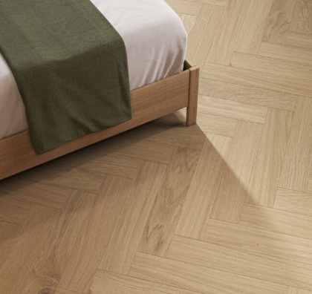
More reasons to choose Tarkett iD Classics Glue-Down 30

- 100% Phthalate free
- 100% recyclable offcuts & post-use
- Optimal indoor air quality
- Test reports and certificates available upon request

- TVOC ≤ 100 μg/m³ after 28 days
- TEKTANIUM
- Made in Europe

